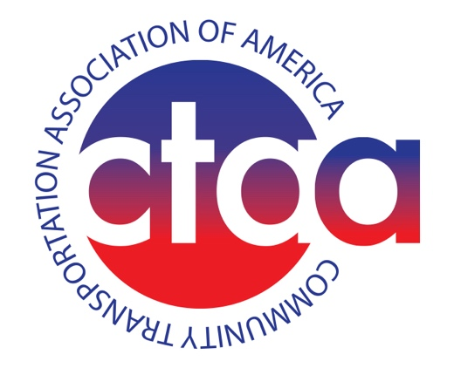

**CTAA Statement of Support for the *INVEST in America Act***

"On behalf of the Community Transportation Association of America's (CTAA) more than 1,300 members, we applaud the House Transportation and Infrastructure Committee for introducing a surface transportation reauthorization bill that provides much needed investment into our nation’s community and public transit sector.”

“This important piece of legislation sets forth record-level investments into the key formula programs for CTAA members (Sections 5307, 5310, 5311 and 5339) and introduces a number of vital, innovative new concepts into the public transit space. These unprecedented funding levels create more opportunities for rural, tribal, specialized and small-urban transit providers to invest in low-emission vehicles, offer innovative mobility solutions to their community and introduce right-sized transit technology options into their operations.”

“Additionally, we are relieved to see the Committee removed an unnecessary addition on CDL licensing that would require all those transporting eight or more passengers to obtain a CDL license. Removing this requirement from this reauthorization bill is a great relief for community and public transit providers.”

"We are looking forward to working with the full Committee and Congress in a bi-partisan fashion to advance our nation’s next surface transportation bill.”- Scott Bogren, Executive Director, CTAA