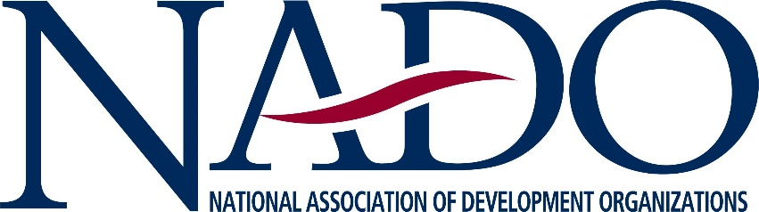

June 08, 2021
The Honorable Peter A. DeFazio
Chairman
House Transportation and Infrastructure Committee
Washington, D.C. 20515

Dear Chairman DeFazio,

On behalf of the National Association of Development Organizations (NADO) and the more than 500 Regional Development Organizations (RDOs) that NADO represents across the country, I am writing to express our strong support for the Investing in a New Vision for the Environment and Surface Transportation (INVEST) Act. This bill is a significant step forward on many levels within the transportation arena.

NADO’s membership is comprised of a national network of multi-jurisdictional regional planning and development organizations. These public-based entities play an invaluable role in fostering intergovernmental collaboration among federal, state, and local officials. They deliver and manage various federal and state programs. Most importantly, they work to solve regional issues and to address the fundamental building blocks required for competitive and sustainable communities and economies.

We are eager to express our support for the INVEST Act because it significantly increases funding for transportation planning – something our members care deeply about given their responsibilities and participation in the transportation planning process. The INVEST Act also increases the percentage of STP funds that will be suballocated based on population from 55 percent under current law to 60 percent over the life of the bill.

The bill also increases access to several grant programs, makes changes to state DOT operations that should make it easier for local governments and planning organizations to work more closely with state DOTs, and codifies several new local governmental responsibilities such as resiliency planning – something many of our members are already engaged in.

The bill also directs state DOTs to prioritize “complete and context sensitive design” including design for all users of the transportation system, prioritizes operational performance, and instructs project sponsors to design in a manner that reflects local priorities and context as opposed to requiring that transportation facilities be built in a “one size fits all” approach.

We are also pleased to see increased funding levels for the Transportation Alternatives Program (TAP) and new limitations on the transferability of TAP funds, are encouraged by the newly dedicated funding for bridges and bridge replacement, substantial funding levels for Projects of Regional and National Significance, and authorizations for new programs such as the Community Transportation Investment Program, Community Climate Innovation Grants, and Active Transportation Connectivity Grants.
We look forward to continuing to express our support for this legislation as it begins to move through the legislative process,

Sincerely,
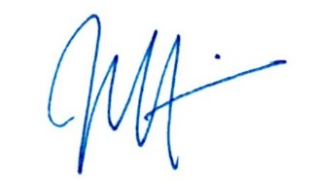
Joe McKinney
Executive Director
National Association of Development Organizations

