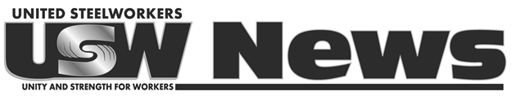

**For Immediate Release:** July 1, 2021

**Contact:** Jess Kamm Broomell, 412-562-2444, [jkamm@usw.org](mailto:jkamm@usw.org)

**USW Welcomes House Passage of INVEST in America Act, Calls for Continued Action on Infrastructure**

(PITTSBURGH) – *United Steelworkers (USW) International President Tom Conway issued the following statement today after the U.S. House of Representatives passed the INVEST in America Act, which would provide more than $700 billion for transportation and water infrastructure:*

“The USW welcomes today’s House passage of the INVEST in America Act as a significant step toward repairing our nation’s critical infrastructure, making our communities safer and sustaining and creating millions of good jobs.

“Thanks to the leadership of House Transportation and Infrastructure Committee Chairman Peter DeFazio, this bill not only provides badly needed funds for our transportation networks and water systems, but also lays a framework to strengthen domestic procurement provisions and require regular waiver reviews that will ensure American workers will reap the full benefit of this investment.

“This is the kind of forward thinking that we need as we engage in what must be a larger, ongoing effort to rebuild our infrastructure, revitalize our communities and reinvigorate our economy.

“We look forward to working with both the White House and Congress as we make this transformational infrastructure initiative a reality.”

The USW represents 850,000 men and women employed in metals, mining, pulp and paper, rubber, chemicals, glass, auto supply and the energy-producing industries, along with a growing number of workers in health care, public sector, higher education, tech and service occupations.

###