 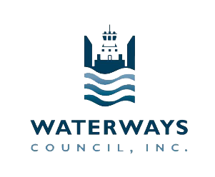

December 7, 2020

The Honorable Peter DeFazio The Honorable Sam Graves  
Chairman                 Ranking Member   
Committee on Transportation and Infrastructure          Committee on Transportation and Infrastructure

U.S. House of Representatives   U.S. House of Representatives    
Washington, DC 20515  Washington, DC 20515

The Honorable John Barrasso                                             The Honorable Thomas R. Carper   
Chairman                                                                                 Ranking Member    
Committee on Environment & Public Works Committee on Environment & Public Works

U.S Senate U.S. Senate

Washington, DC 20510                                                        Washington, DC 20510

Dear Chairman DeFazio, Chairman Barrasso, and Ranking Member Graves and Ranking Member Carper:

The members of American Waterways Operators (AWO) and Waterways Council, Inc. (WCI) thank you for your leadership and commitment to the Water Resources and Development Act (WRDA) biennial process.

America’s inland waterways system includes 12,000 miles of commercially operated and maintained navigable channels that directly affect 38 states. The inland waterways system is tasked with transporting the nation’s bulk commodities that keep America competitive in the most energy-efficient and environmentally friendly way. In 2016, 558 million tons of commodities valued at $300 billion transited the waterways, supporting 541,000 American jobs.

AWO and WCI thank you for Section 109 of WRDA 2020. This section adjusts the cost-share formula for the construction and major rehabilitation of inland waterways navigation projects from the current 50 percent general revenues and 50 percent Inland Waterways Trust Fund (IWTF) to 65 percent general revenues and 35 percent IWTF for 10 years. This policy will help significantly expedite the completion of inland waterways construction and major rehabilitation projects during the applicable years.

AWO and WCI also appreciate the inclusion of specific provisions in the final conference report:

* Section 151, which will provide the Corps of Engineers the additional flexibility to deploy nearby dredges in a timely manner to sections of the inland waterways system impaired or otherwise affected by high- and low-water events;
* The Kentucky Lock adjustment, which will ensure that construction of the project will not be impeded by authorized cost constraints;
* The Chief’s Report for the Gulf Intracoastal Waterway, Brazos River Floodgates and Colorado River Locks, which will improve navigation on the Gulf Intracoastal Waterway; and
* The Missouri River Basin comprehensive review language, which will enhance recent efforts that have enhanced commercial navigation activity on this crucial waterway.

Enactment of WRDA 2020 is critical to ensuring waterways reliability to keep America competitive. AWO and WCI offer our full support for passing this critical legislation.  

Sincerely,

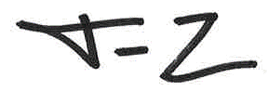  
  
Jennifer Carpenter Tracy Zea

President and CEO President and CEO

American Waterways Operators Waterways Council, Inc.